PROJECT DESIGN PHASE - 1 PROBLEM SOLUTION FIT

|  |  |
| --- | --- |
| DATE | 22 November 2022 |
| TEAM ID | PNT2022TMID25156 |
| PROJECT NAME | STATISTICAL MACHINE LEARNING APPROACHES TO LIVER DISEASE PREDICTION |
| MAXIMUM MARK | 2 Marks |

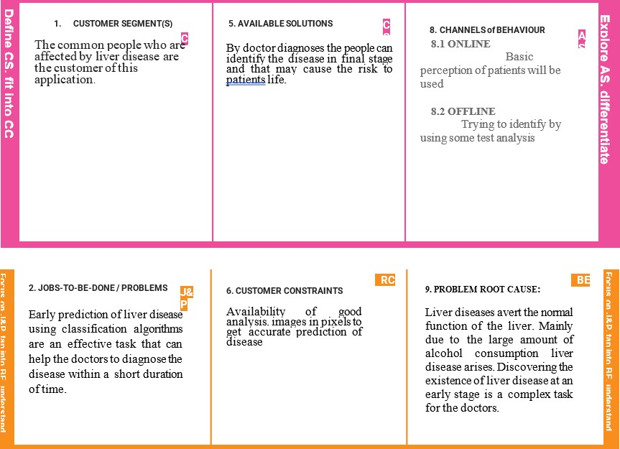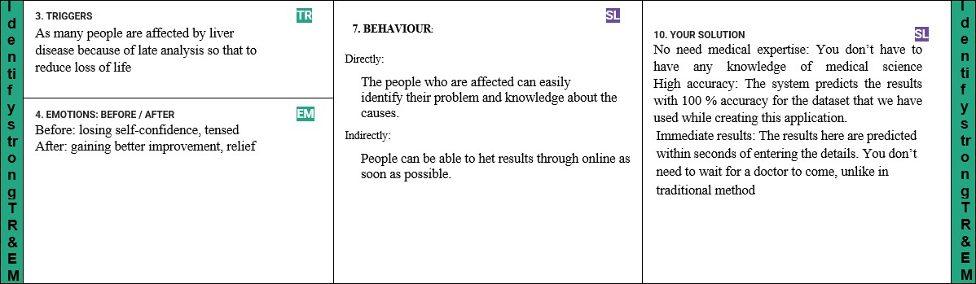Problem Solution Fit: